33.55: a) 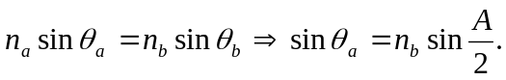
But 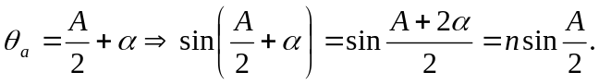
At each face of the prism the deviation is 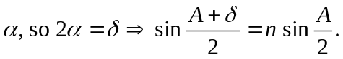
b) From part (a), 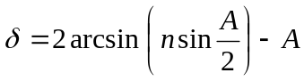
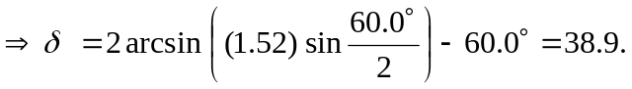
c) If two colors have different indices of refraction for the glass, then the deflection angles for them will differ:
